Draw.io Tutorial

Open Draw.io within your browser.

Select Device

Select Create New Diagram

Enter a filename (Tutorial Diagram.drawio) and select Blank Diagram then press Create

Click More Shapes (see bottom left corner)

Select Software; Mockups and press Apply.

Investigate the different Mockup shapes available to you; Buttons, Containers, Forms, Graphics, Markup, Misc, Navigation and Text.

Open Mockup Buttons. Drag the first icon button to your drawing grid. Type in Submit. Click off the control.

Control selection. Click on the button.

Styling: Look to the right side of the screen. Here you can change the Style of the button, Text of the button and its Arrangment. Select Style and change the Fill. Turn on the Shadow. Select Gradient and investigate directions.

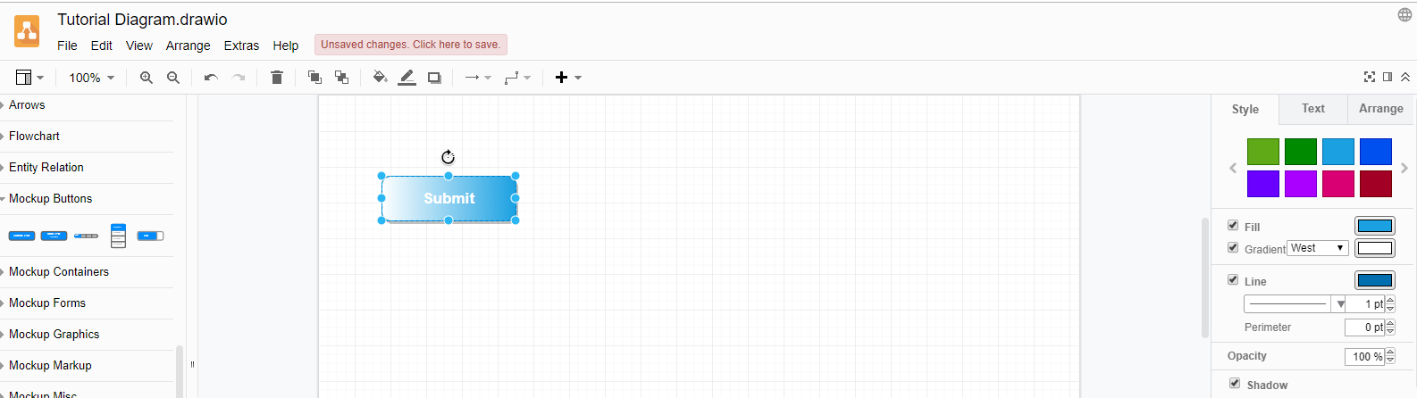

Text: Select Text styling. Change your font. Explore B I and U. Change your font size. You can position. Change the Font color. Background Color only changes the color around the text NOT the color of the button.

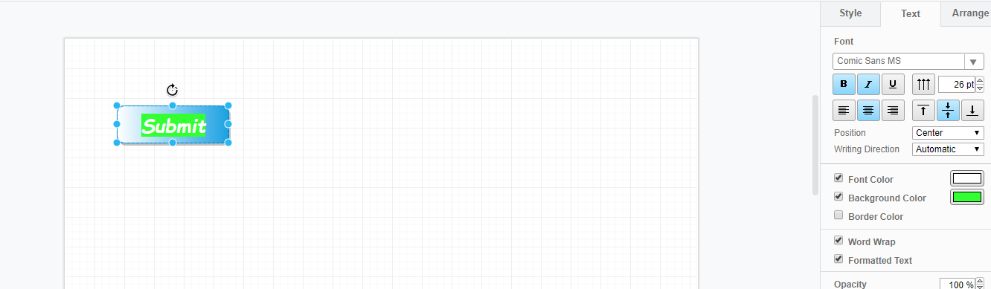

Arrange: Explore various options.

Open Mockup Forms. Investigate the different control images. Select ComboBox and drag to your grid area.

Enter Frozen. This will change the text of the control. Click off the control. Reselect the control and you have all the styling as for the button.

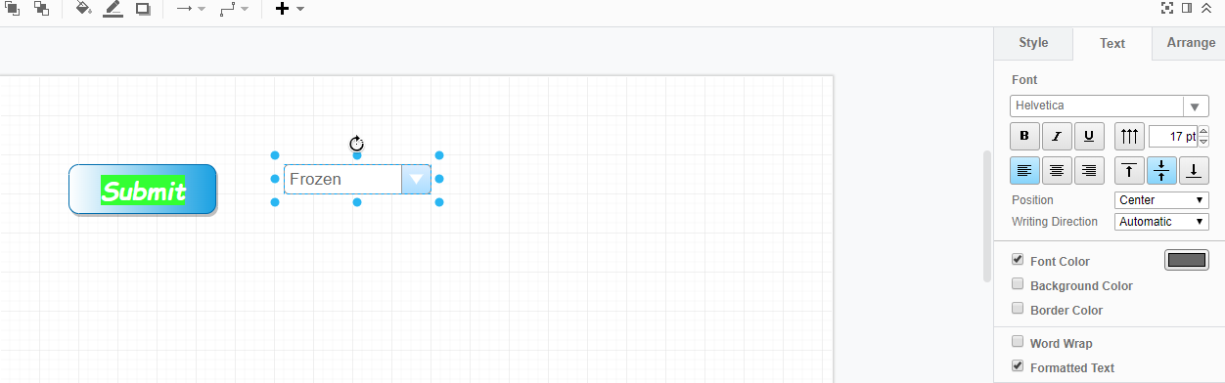

Table type controls (GridView): Select Mockup Text, select Table (last image), and drag to grid. Double click one of the cells in the table. In the lower right corner should be a set of icons to add and delete columns and rows. You can single, double or triple click in a cell to position cursor, select a word or select cell contents. Change the first header to Name and the second to Phone. Change the cells to be Bob and 3445 for the first row; Mary and 3448 for the second row. Select any cell in the second column then click Insert column right. Enter City in the column header. The alignment may not match Phone. Delete the text. Double click Phone, copy and paste in the new column header. Add a new row. Add Pat, 3333, St Albert. For Bob and Mary add Edmonton. You will need to select a bottom anchor point and drag it down to increase the size of the table, thus seeing your new row.

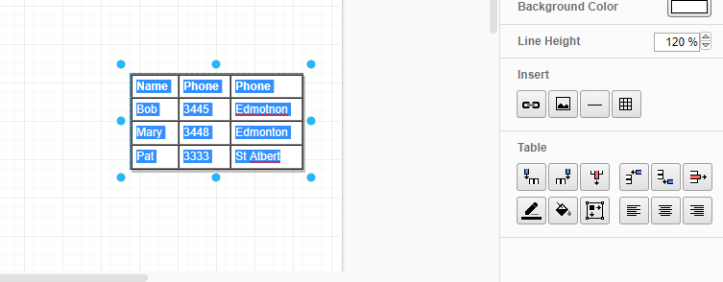

|  |  |
| --- | --- |
| Drag the Sticky note to your grid. Select the text and apply the instructions in the sticky note to your right. |  |

Creating a Yellow circle. Open the General group (at the top). Drag a Text icon to your grid area. Change the text string to the number 1, bold. Select the style tab. Change the Fill to yellow. Turn on Line and Rounded. You should see an orange anchor spot in the upper right corner of the yellow rounded rectangle. Drag the orange anchor spot to your left to increase the rounded corners. You may have to adjust the blue anchor tags to create the circle.

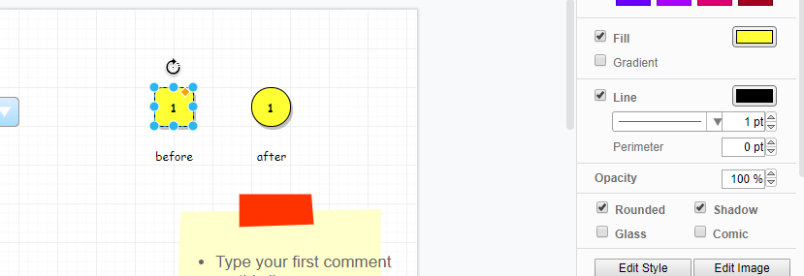

At the top of your grid, you should see a pinkish message to click here to save. The drawio file should be in your downloads folder. You can also Export your drawing as an image. Select File/Export as/… :Your image will be downloaded to your downloads folder.